https://shorturl.at/G2IAP 29 Jan 2025
30 Jan 2025

G17 BEE
- Middlewares (Deep Dive)

=================================================
Middleware Deep Dive (For Practice, Applications out of scope currently)
=================================================

- Application-level Middleware

//initialyse project
//>npm init -y
//download express module
//>yarn add express --save
// Define port
const port = 8080
// Import the express module
const express = require('express') // Express library for creating the server
//Create rest object
const app = express()

app.listen(port, () => {
console.log(`Server is running on port ${port}`)
})

Eg 1 Logging Incoming Requests
Problem Definition: Demonstrate to log HTTP method and URL for each incoming request using application-level middleware.

// Application-level middleware to log the HTTP method and URL of each incoming request
app.use((req, res, next) => {
console.log(`${req.method} ${req.url}`) // Log the request method and URL
next() // Pass control to the next middleware or route handler
})

app.get('/', (req, res) => {
res.send('Hello, World!') // Respond with 'Hello, World!' when the root URL is accessed
})

/*
Steps to Execute:
>node server
Open a browser or Postman and navigate to `http://localhost:8080/`.
Check your terminal to see the HTTP method and URL being logged for the request.
*/

Eg 2 Setting a Custom Header for All Responses
Problem Definition: To set a custom header (X-Powered-By) for every HTTP response using application-level middleware.

// Application-level middleware to set a custom header for all responses
app.use((req, res, next) => {
res.setHeader('X-Powered-By', 'Express') // Set custom header 'X-Powered-By'
next() // Pass control to the next middleware or route handler
})

app.get('/', (req, res) => {
res.send('Hello, World!') // Respond with 'Hello, World!'
})

/*
Steps to Execute:
>node server
Open a browser or Postman and navigate to `http://localhost:8080/`.
Inspect the response headers in the browser's developer tools or in Postman to see the `X-Powered-By: Express` header.
*/

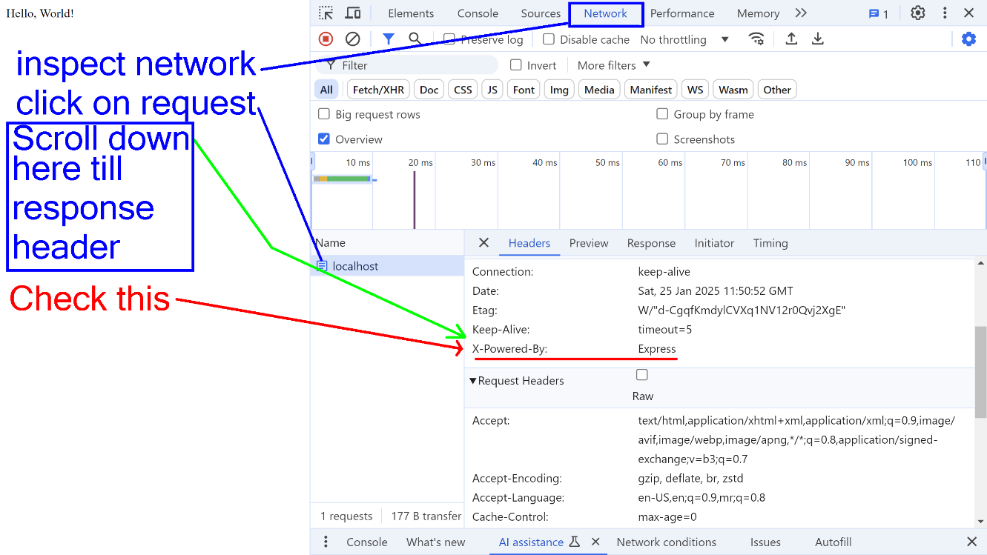

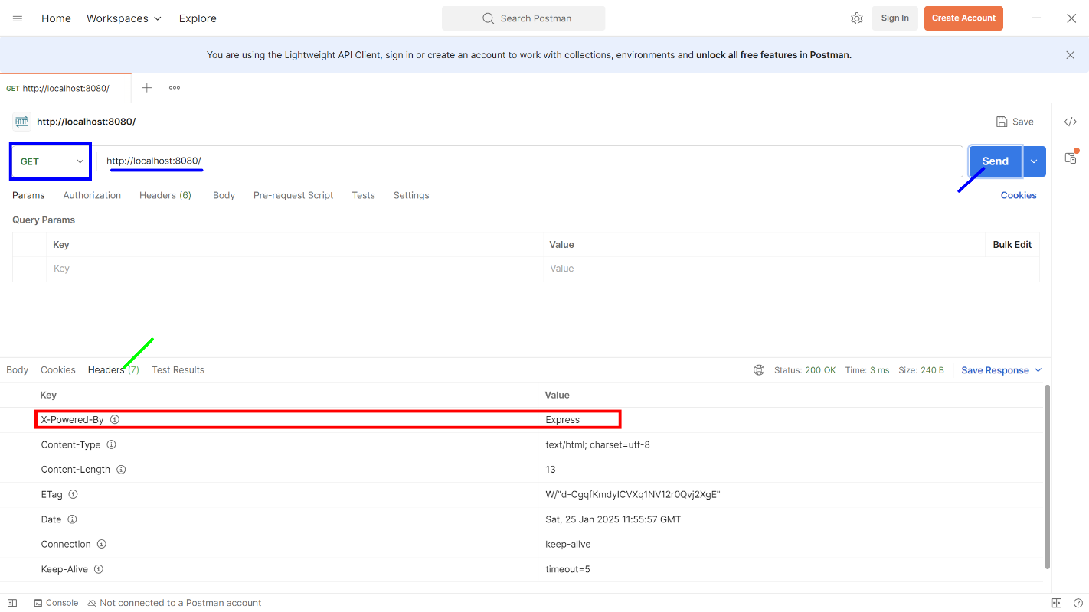

Eg 3 Authentication for All Routes
Problem Definition: Add a basic authentication middleware for all routes, blocking access if no Authorization header is provided.

// Application-level middleware to require authentication for all routes
app.use((req, res, next) => {
if (!req.headers.authorization) { // Check if authorization header exists
return res.status(403).send('Forbidden') // Respond with Forbidden if no authorization
}
next() // Pass control to the next middleware or route handler
})

app.get('/', (req, res) => {
res.send('Hello, World!')
})

/*
Steps to Execute:
>node server
Open Postman and make a GET request to `http://localhost:8080/`.
- Without any `Authorization` header, the response should be `403 Forbidden`.
- Add an `Authorization` header with any value to see the successful response.
*/
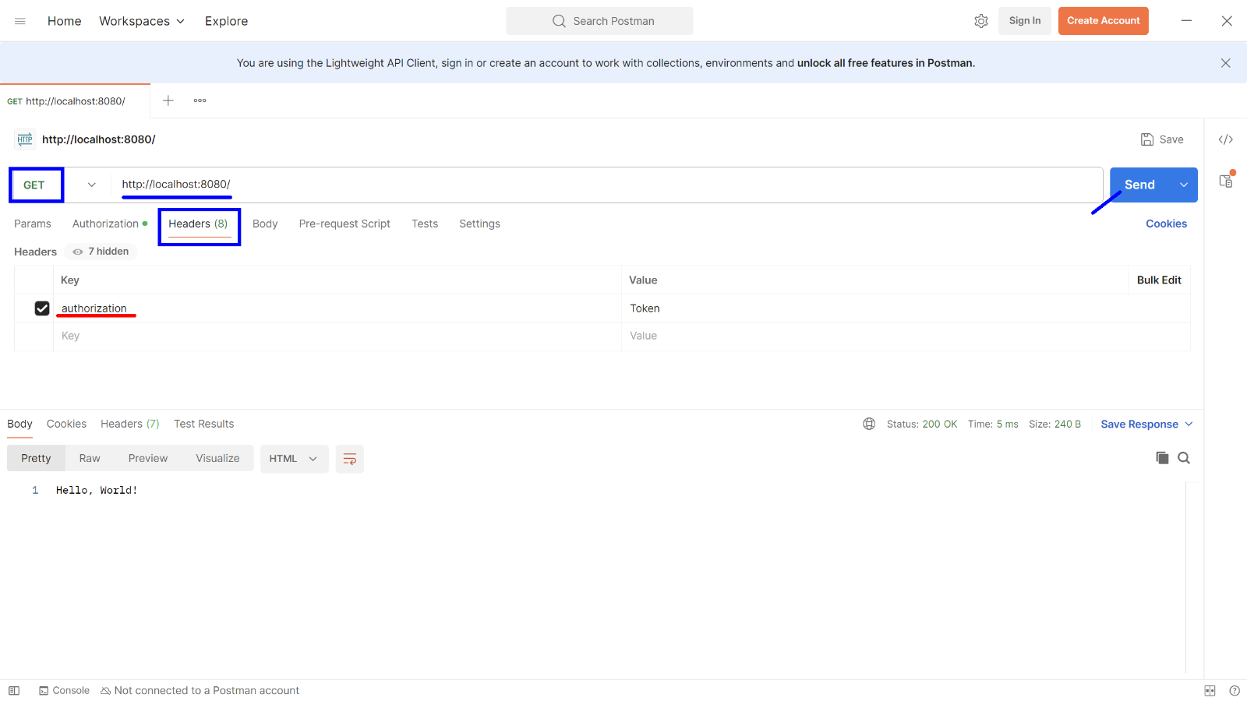

Eg 4 Request Body Parsing
Problem Definition: To use application-level middleware to parse incoming JSON request bodies.

// Application-level middleware to parse incoming JSON request bodies
app.use(express.json()) // Parse JSON body

app.post('/', (req, res) => {
res.send(`Received data: ${JSON.stringify(req.body)}`) // Respond with received data
})

/*
Steps to Execute:
>node server
Open Postman, set the request method to `POST`, and use the URL `http://localhost:8080/`.
In the "Body" section, select `raw`, choose `JSON`, and add data like:
{
"name": "Chitkara University",
"department": "CSE"
}
*/

- Router-level Middleware

//initialyse project
//>npm init -y
//download express module
//>yarn add express --save
//Define port
const port = 8080
// Import the express module
const express = require('express') // Express library for creating the server
//Create rest object
const app = express()
// Create a router instance
const router = express.Router()

app.use('/api', router) // Apply the router to all routes starting with "/api"
app.listen(port, () => {
console.log(`Server is running on port ${port}`)
})

Eg 1 Logging Requests to Specific Routes
Problem Definition: To apply router-level middleware to log requests to specific routes (e.g., `/api/users`).

// Router-level middleware to log requests to "/api" routes
router.use((req, res, next) => {
console.log('Request to /api route:', req.method, req.url)
next() // Pass control to the next middleware or route handler
})
router.get('/users', (req, res) => {
res.send('User list') // Respond with a list of users
})
app.use('/api', router) // Apply the router to all routes starting with "/api"

/*
Steps to Execute:
>node server
Open Postman or your browser and navigate to `http://localhost:8080/api/users`.
Check your terminal for the log output of the HTTP request.
*/

Eg 2 Authorization for User Routes
Problem Definition: To implement route-specific authentication for routes related to users.

// Router-level middleware to check authentication for "/users" routes
router.use('/users', (req, res, next) => {
if (!req.headers.authorization) { // Check if user is authenticated
return res.status(401).send('Unauthorized') // Respond with Unauthorized if not authenticated
}
next() // Pass control to the next middleware or route handler
})
router.get('/users', (req, res) => {
res.send('User list') // Respond with a list of users
})
app.use('/api', router) // Apply the router to all routes starting with "/api"

/*
Steps to Execute:
>node server
Open Postman and navigate to `http://localhost:8080/api/users`.
Without an authentication middleware, you’ll get a `401 Unauthorized` response unless authentication is set up.
*/

Eg 3 Caching Data for Routes
Problem Definition: To implement a simple caching mechanism at the router level for a /products route.

// Simple in-memory cache object
const cache = {}
// Router-level middleware to cache data for "/products" routes
router.use('/products', (req, res, next) => {
if (cache[req.url]) { // Check if the request URL is cached
return res.json(cache[req.url]) // Serve cached data
}
next() // Continue to the next handler if no cache exists
})
router.get('/products', (req, res) => {
const products = [{ id: 1, name: 'Product 1' }]
cache[req.url] = products // Cache the response data
res.json(products) // Send the response
})
app.use('/api', router) // Apply the router to routes starting with "/api"

/*
Steps to Execute:
>node server
Open Postman and send a GET request to `http://localhost:8080/api/products`.
The first request will fetch and cache the data. Subsequent requests (if any) will serve the cached data.
*/

Eg 4 Limiting Number of Requests
Problem Definition: implement rate limiting for a /data route, allowing a limited number of requests.

let requestCount = 0
const RATE_LIMIT = 5
// Router-level middleware to limit requests for "/api" routes
router.use((req, res, next) => {
requestCount++ // Increment request counter
if (requestCount > RATE_LIMIT) { // Check if the rate limit is exceeded
return res.status(429).send('Too many requests') // Respond with Too many requests
}
next() // Continue to the next handler
})
router.get('/api/', (req, res) => {
res.send('Data accessed')
})
app.use(router) // Apply the router

/*
Steps to Execute:
>node server
Open Postman and send multiple GET requests to `http://localhost:8080/api/`.
After reaching the rate limit (5 requests), you will receive a `429 Too many requests` response.
*/

3. Error-handling Middleware
//initialyse project
//>npm init -y
//download express module
//>yarn add express --save
//Define port
const port = 8080
// Import the express module
const express = require('express') // Express library for creating the server
//Create rest object
const app = express()

app.listen(port, () => {
console.log(`Server is running on port ${port}`)
})

Eg 1 Basic Error Handling Middleware
Problem Definition: The server might encounter unexpected errors, so we need to handle them gracefully.

// Define a route that triggers an error
// Simulate an error by passing it to the next middleware
app.get('/', (req, res, next) => {
const error = new Error('Something went wrong') // Simulate an error
next(error) // Pass the error to the next middleware
})

// Error-handling middleware function
// Logs the error stack and sends a 500 error response
app.use((err, req, res, next) => {
console.error(err.stack) // Log the error stack trace for debugging
res.status(500).send('Something went wrong!') // Respond with a 500 status and error message
})

/*
Steps to Execute:
>node server
Visit http://localhost:8080/ to simulate the error
*/

